Introduction: In this topic you will learn how matrices, mainly the concept of rank help us in analyzing the system of linear equations and finding its solution.
Matrices:
Matrix: A matrix is a rectangular array of numbers; the numbers in the array are called the elements of the matrix.
The size of the matrix is described in terms of the number of rows (Horizontal lines) and number of columns (Vertical lines). The matrix having m-rows and n-columns is denoted by
Types of Matrices:
Row Matrix or Row vector: Matrix having one row.
Column Matrix or Column vector: Matrix having one column.
Square Matrix: Matrix having same number of rows and columns.
Upper triangular matrix: 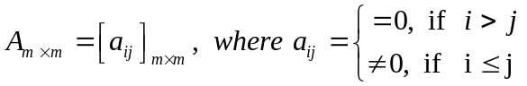.
Lower triangular matrix: 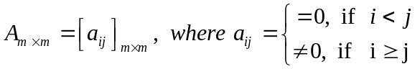.
Diagonal Matrix: 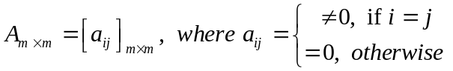.
Scalar Matrix: 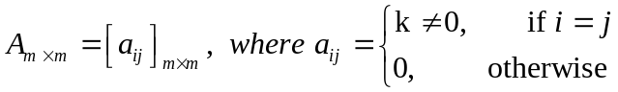.
Unit Matrix: 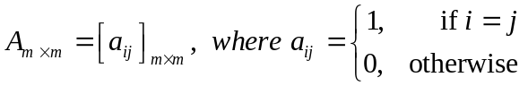.
Null Matrix: A matrix having all elements zero.
Matrix Algebra:
1. Equality of Matrices: Matrix A and B are said to be equal if and only if
i) A and B are of same order and
ii) corresponding elements of A and B are equal.
2. Addition of Matrices: The matrices A and B are said to be compatible for addition if and only if they are same order. The sum of A and B denoted by A+B is obtained by adding corresponding elements.
3. Scalar Multiplication: If A is any matrix and c is any scalar, then the product cA is the matrix obtained by multiplying each element of matrix A by c.
Properties of Addition and Scalar multiplication:
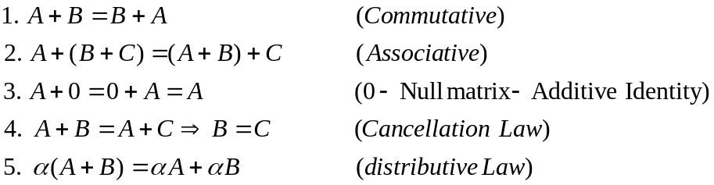

4. Multiplication: The matrices A and B are said to be compatible for multiplication 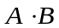I, if number columns of A is equals to number of rows of B.
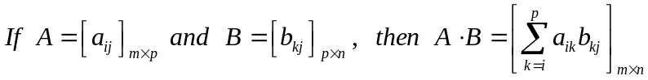
Properties Matrix multiplication:
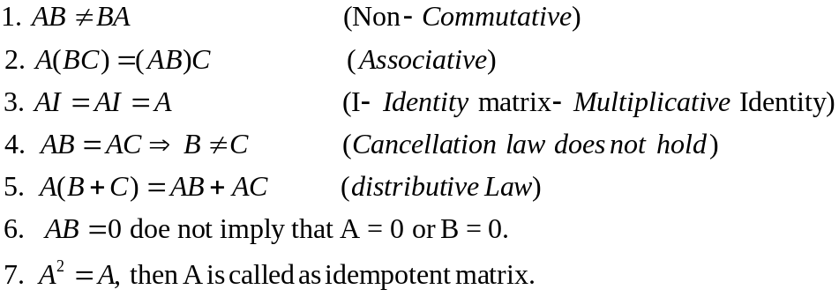
Matrix Product as a Linear combination
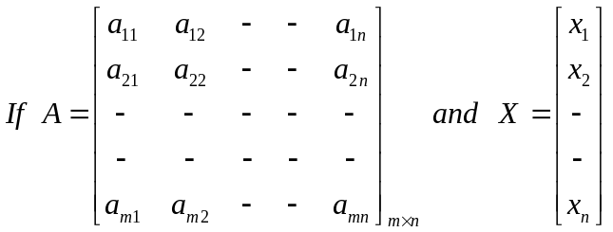 Then 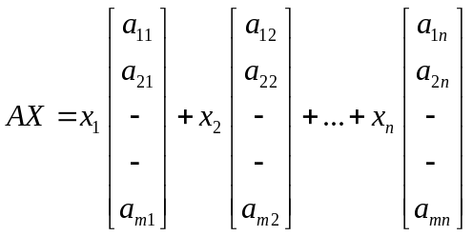
Transpose of a Matrix: : If is any matrix, then transpose of A, denoted by 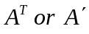 ,
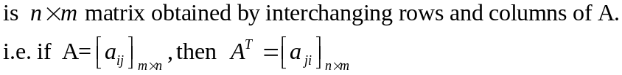
Properties of Transpose of a Matrix:
Trace of a Matrix: Let A be a square matrix, then Trace of A, denoted by tr(A) is sum of the entries in the main diagonal of A.
Determinant of a Matrix: Let A be a square matrix, then determinant of A, denoted by det(A) or |A| is the value of the determinant of A.
Singular Matrix: Let A be a square matrix, if determinant of A = 0, then A is said to singular matrix otherwise it is said to be non-singular matrix.
Minor of an i-jth element of the Matrix: The determinant obtained by deleting the i-th row and j-th column of a matrix.
Cofactor of an i-jth element of the Matrix:
Cofactor Matrix: The Matrix obtained by replacing each element of A by its cofactor.
Adjoint Matrix: The transpose of the cofactor matrix.
Inverse of A Matrix: Let A be non-singular matrix, Matrix B is said to be inverse of A if and only if 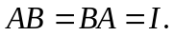
Properties of Inverse of a Matrix: 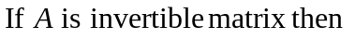

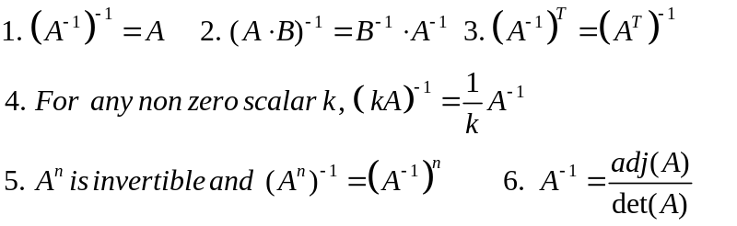
Symmetric Matrix: A square matrix A is said to be symmetric if and only if 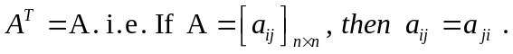
Skew Symmetric Matrix: A square matrix A is said to be skew symmetric if and only if
Example: Show that every square matrix can be expressed as sum of symmetric and skew symmetric matrices.
Rank of a Matrix : Let 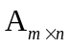 be any matrix, 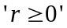 is said to a rank of the matrix A denoted as 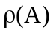 if the matrix has
- at least 1 non-zero minor of order 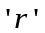
- all the minors of order 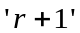 are zero.
OR The order of highest order non-vanishing minor is the rank of the matrix.
OR The order of highest order non-vanishing determinant present in the matrix is the rank of the matrix.
Elementary Transformations:
- Interchange of any two rows or columns
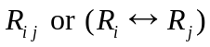 , 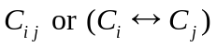 .
- Multiplying any row or column by a non-zero constant , 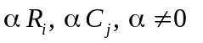
- Adding in 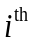 row a scalar multiple of corresponding elements of 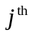 row (similarly for column) 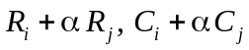
# Theorem: Elementary transformations do not alter the rank of the matrix.
Echelon Form (Row reduced form)
(To reduce a matrix into an Echelon form, only row transformations are permitted.)
- All the non-zero rows are above any rows of zeros.
- All elements (entries) below the leading element (entry) must be zero.
- Each leading entry of a row is in a column of the right of the leading entry of the row above it.
- All entries in a column below the leading entry all zeros.
Leading entry – First non-zero element in a row called as leading entry or pivot element.
e.g.
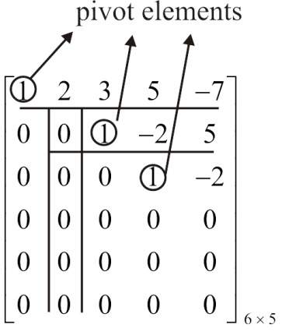 | Pivot elements are the elements whose position should not be altered by application of row transformations.
Equivalent Matrices : - B is said to be an equivalent matrix of A, shown as 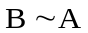 iff B is obtained by applying elementary transformations on A.
For a matrix 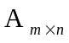
- Rank of A, 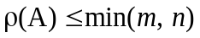
- Number of pivot elements in an Echelon form is the rank of the matrix.
- If A is a nonsingular matrix of order n, then 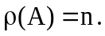
- If A is a nonsingular matrix of order n, then
Elementary Matrix:- A matrix obtained by applying a single elementary row transformations on identity matrix is called Elementary Matrix.
Note:
- Every Elementary Matrix is invertible, and inverse of an elementary matrix is an elementary matrix.
- Elementary row transformation correspondence to left multiplication by corresponding elementary matrix.
- Similarly Elementary column transformation correspondence to right multiplication by corresponding elementary matrix.
Theorem: Every non-singular matrix can be expressed as a product of elementary matrices.
Example: Express 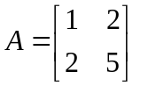as a product of an elementary matrices
Solution:
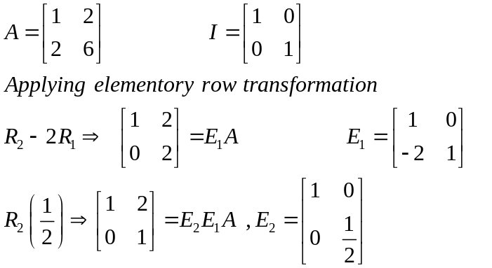

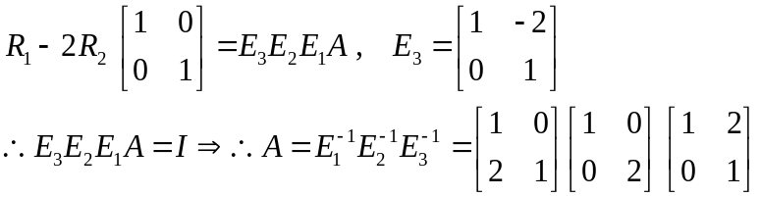
Illustrative Examples:

- Find the rank of the matrix by reducing it to an Echelon form.
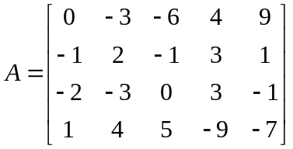
Sol^{n}. 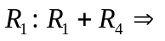
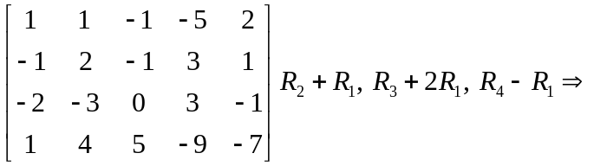

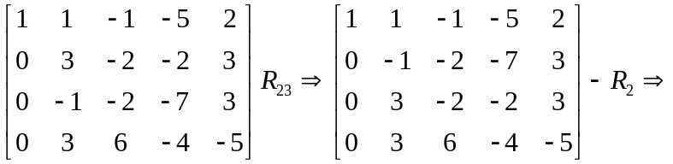
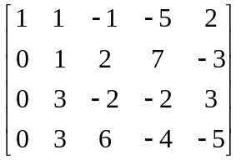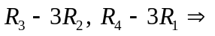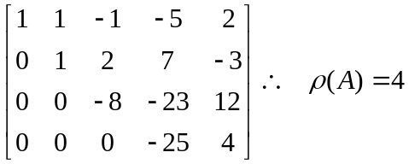
- Find the rank of the matrix by reducing it to an Echelon form.
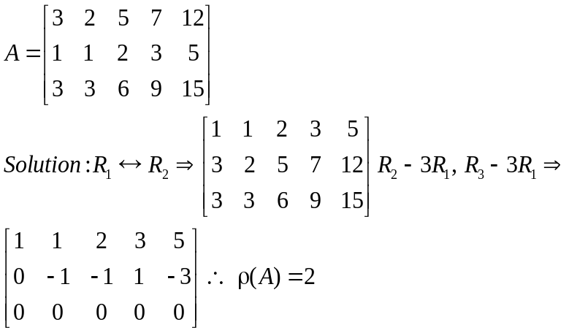
System of Linear Equations
Consider a system of m equations and n unknowns.
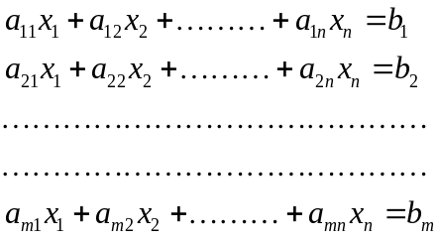

The above system of equation can be written in the matrix form as 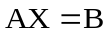
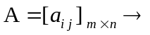coefficient matrix 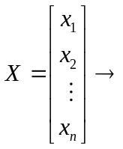 Matrix of unknowns and 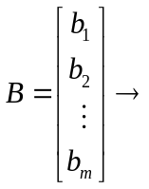 Matrix of constants
- If 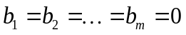, then it is said to be Homogeneous System of Linear equations.
- If at least one of 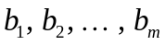 is non-zero, then it is said to be Non-homogeneous System of Linear equations.
- Results
- Homogeneous system of Linear equations is always consistent because one of the solutions is 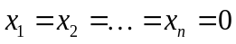 called as ‘Trivial Solution’.
# Augmented Matrix denoted as 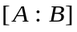 is the matrix obtained by attaching additional column B to matrix A. 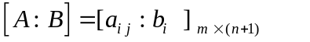
- If rank of augmented matrix is equal to rank of coefficient matrix, i.e.
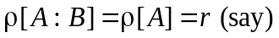 Then, the system of linear equations is consistent.
Note: 1) If (number of unknowns), then the system has a unique solution.
2) In case of homogeneous system, unique solution is a Trivial solution.
3) If , then the system has infinite number of solutions.
4) If , then 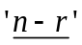 variables are “free variables.”
5) Non-pivot variable is considered as a free variable.
Note: A homogeneous system having n equations in n unknowns, has infinite solutions if and only if determinant of the coefficient matrix is zero.
Illustrative Examples
Check the consistency of following systems. If consistent, find the solution.
- 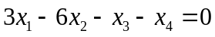
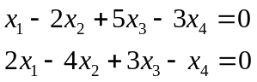
Solution. The system is homogeneous, it is consistent.
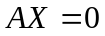, where 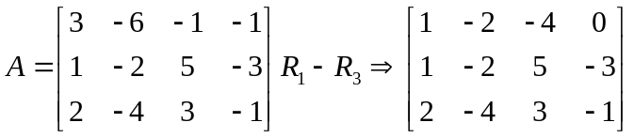

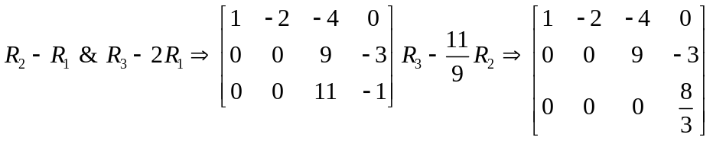
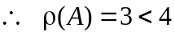, system has a non-trivial solution.
Equivalent system is
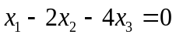 ---------- (i) 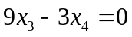 ---------- (ii)
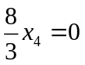 ---------- (iii) From (iii), 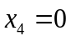 ---------- (iv)
From (ii) & (iv), 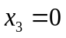 Here 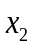 is a free variable (as is a non-pivot element)
Let 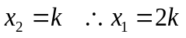
Solution vector 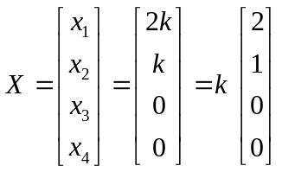
- Investigate the values of 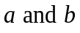 so that the equations
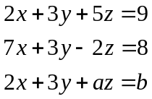
have (i) no solution (ii) unique solution (iii) infinite solutions.
Solution. 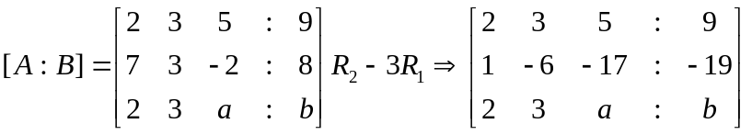

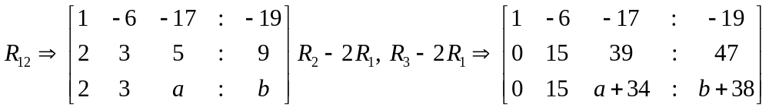

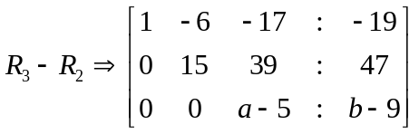
- For no solution, 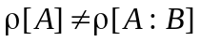 i.e. if 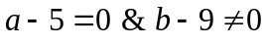 then 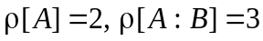
- For unique solution, 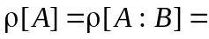number of unknowns. i.e. if 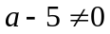 then 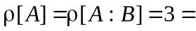number of unknowns.
- For infinite solutions, 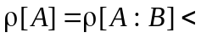 number of unknowns. i.e. if 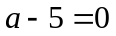 & 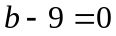 then 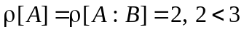 (number of unknowns)
Q 3) Solve the following system of equations by using Gauss-Jordan method
4x–3y–9z+6w=0; 2x+3y+3z+6w=6; 4x–21y–39z–6w= –24;
Solution. Consider
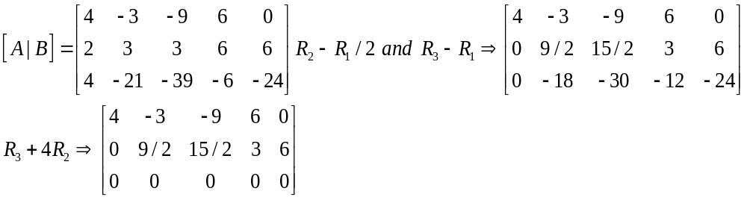
As number of unknowns, therefore system is consistent and has infinite solutions. Here z and w are non-pivot variables, considering them as free variables.
Equivalent system is
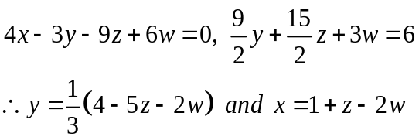
Q 4) Show that the system of equations ax + by + cz = 0, bx + cy + az = 0 and cx + ay + bz = 0 have a non trivial solution if ( i) a + b + c = 0 (ii) a = b = c and solve them completely.
Solution. i) The given system is homogeneous
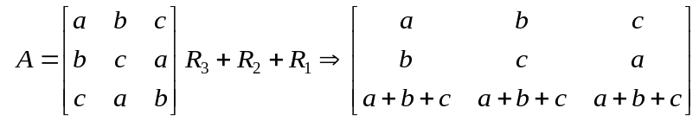
For infinitely many solutions rank of A should be less than 3
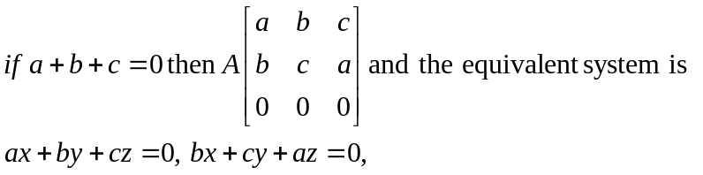
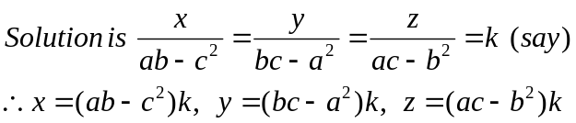
ii) The given system is homogeneous
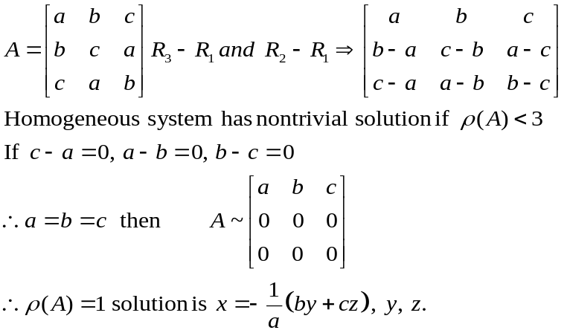
Q 5) Find the values of such that the system has non-trivial solution and solve it completely
for each value of .
Solution: The given system is homogeneous
